# Open EHS Deployment Documentation

1. Obtain the latest version of the Open EHS software from the Weber State University Computer Science Department
2. Open up ‘C:\inetpub\wwwroot’ on the server and copy all the contents from the ‘bin’ folder into the ‘wwwroot’ folder
3. Install MySQL on the server. Go to ‘http://www.mysql.com/downloads/’ and download and install the following pieces:
   1. MySQL Community Server
   2. MySQL Workbench
   3. Connector/ODBC
   4. Connecter/NET

When prompted to select any configuration options just continue with the default option that is selected. For more information on installing MySQL Community Server, open up the document ‘OpenEHS - MySQL Installation’ for an installation walkthrough.

1. Open the MySQL Workbench

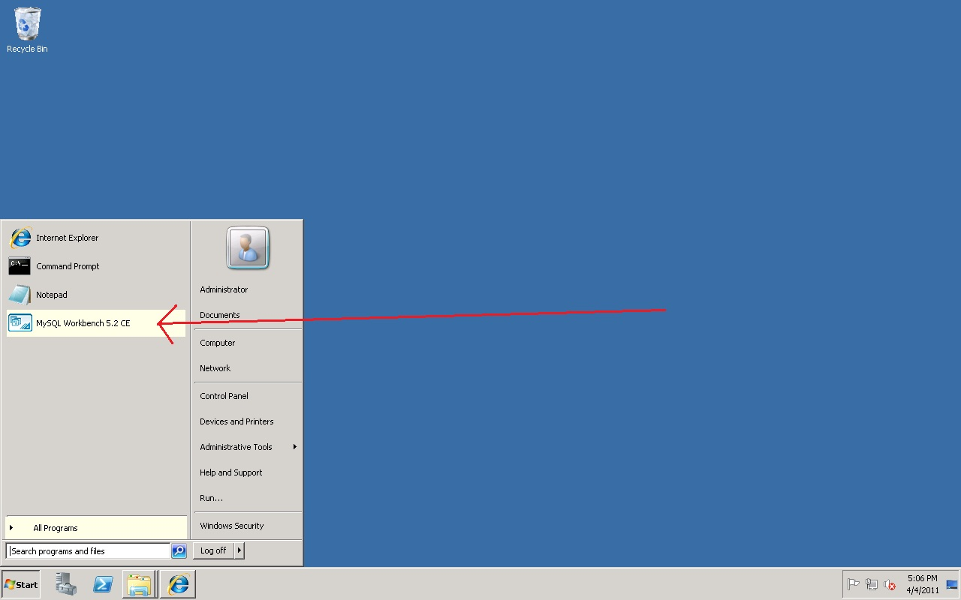

1. Open the Local instance of MySQL

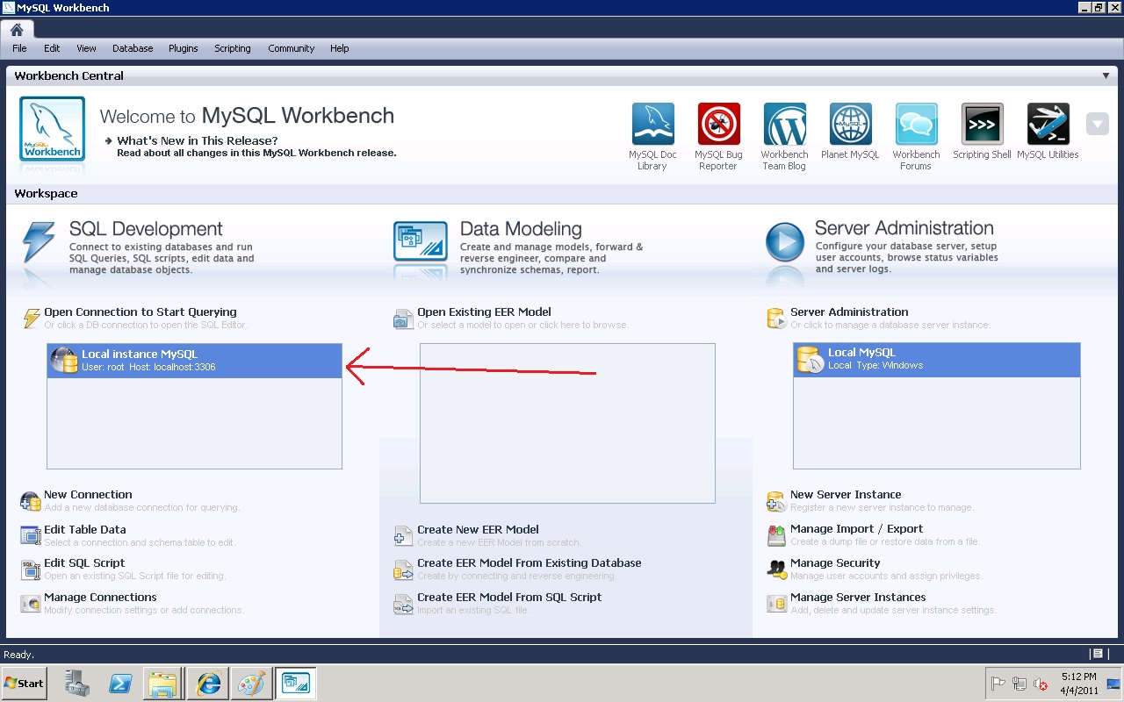

1. Open the ‘OpenEHS’ Database Full.sql’ file in notepad and copy the contents into the Query1 window (Note: If this is the first time you are setting up the database follow the ‘First Time Run Instructions.txt’). Run the script by clicking the lightning bolt button at the top.

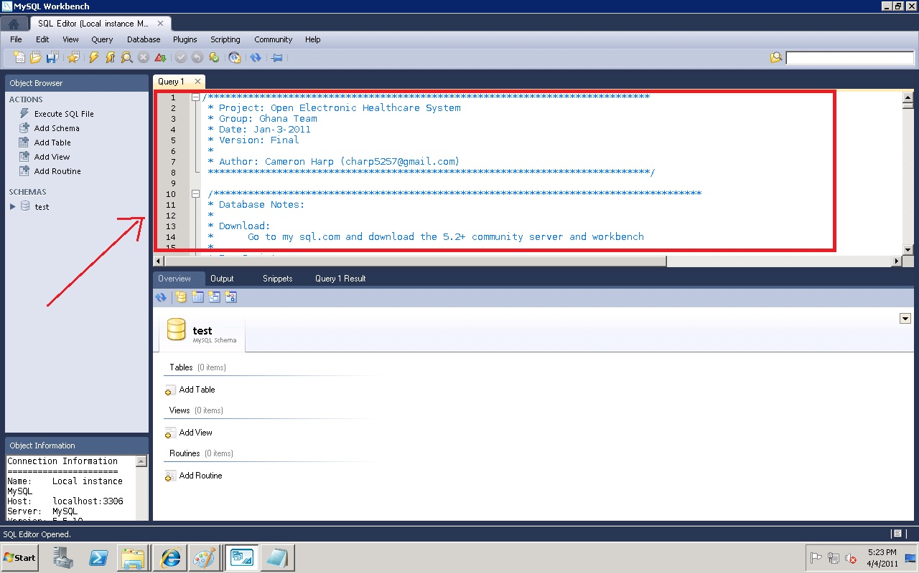

1. Install ASP.NET MVC 3 on the server. This can be found at <http://www.asp.net/mvc/mvc3> or by searching on the internet for an installer.
2. Open the IIS Manager by typing ‘inetmgr’ in the Run Console

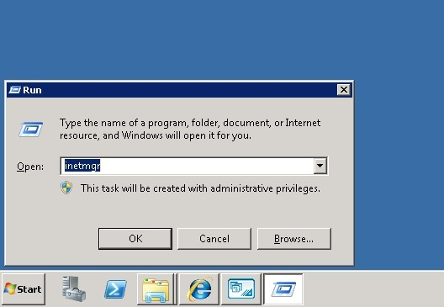

1. In the ‘Application Pools’ check if there is an application pool with the .NET Framework Version set to v4.0.

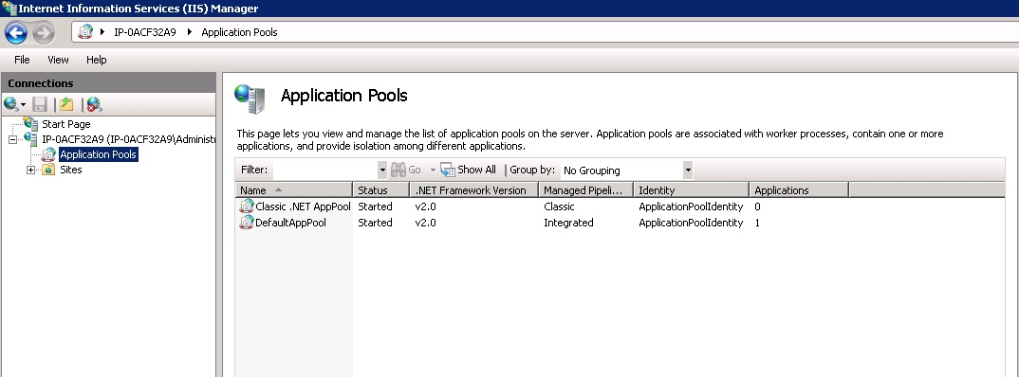

If there is not an exisiting .NET 4.0 pool then a new application pool will need to be setup:

* 1. Right-click on Application Pools and select ‘Add Application Pool…’

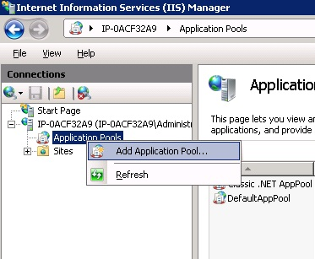

* 1. In the ‘Add Application Pool’ window type in a Name
  2. Select the .NET Framework version as ‘.NET Framework v4.0.xxxxx’
  3. Make sure the ‘Managed pipeline mode’ is set to ‘Integrated’
  4. Set the ‘Start application pool immediately’ to be checked
  5. Click OK

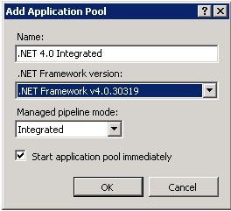

1. Open the Default Web Site by expanding the ‘Sites’ folder in the IIS Manager
2. Click on the ‘Advanced Settings’
3. Click on the Application Pool line and click the ellipsis button with the … inside of it
4. Set the ‘Application Pool’ picklist to use your newly created .NET 4.0 Application Pool
5. Click OK

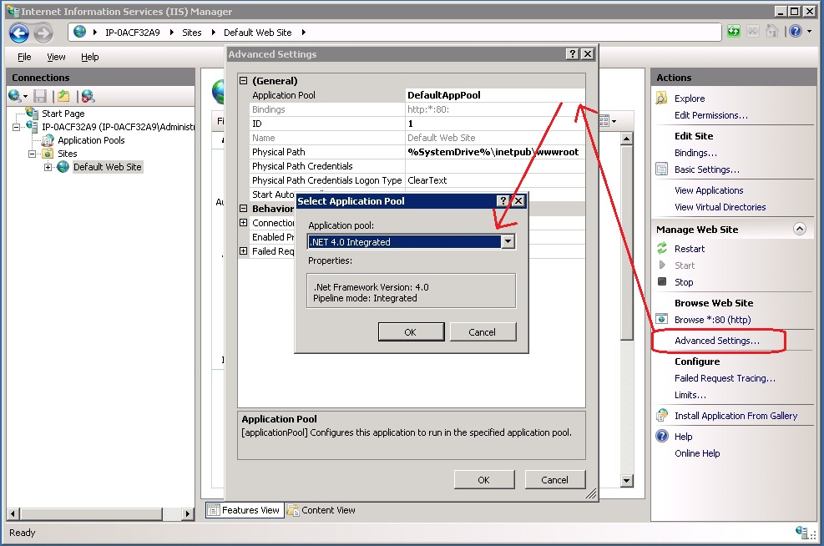

1. Download the latest build from <http://code.google.com/p/openehs/downloads>.
2. Extract all files to C:/inetpub/wwwroot on server.
3. Click on the ‘Browse *:80 (http)’ link to make sure that your website is running correctly

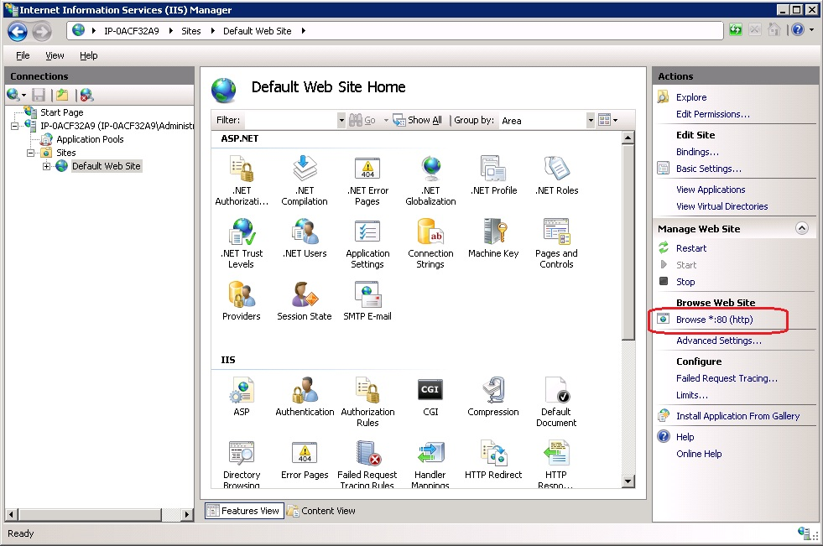

1. You will be taken the login page of the Open EHS website

